**Kishan Sarpangala**

**Assignment 3**

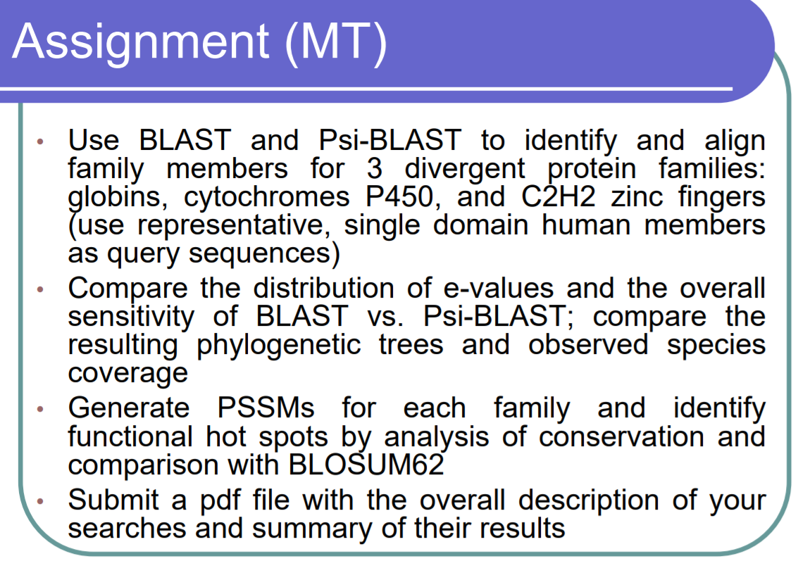

**BLAST RESULTS**

**Neuroglobin**

Blast Result: Neuroglobin Fasta file:

 

Blast Result in Excel format:



Analysis:



Diagram Tree of Neuroglobin

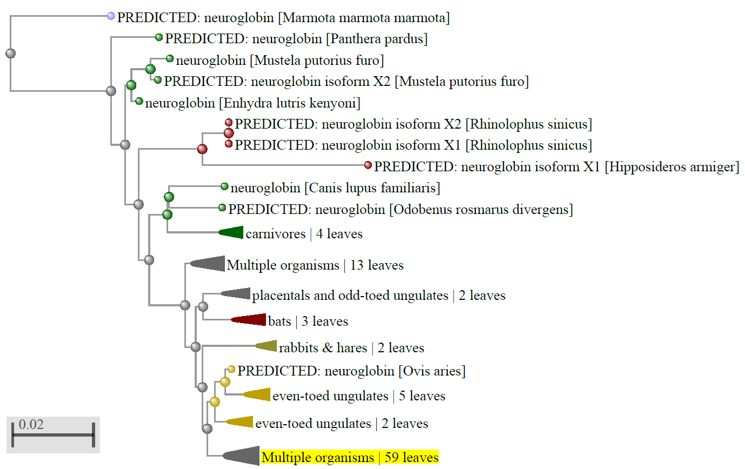

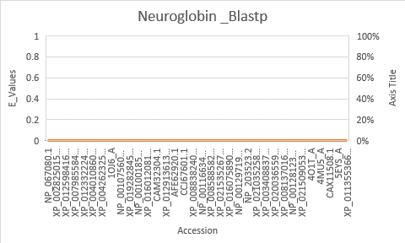

**Cytochromes P450**

**Blast Result**: Cytochromes P450 Fasta file:

 

Blast Result in Excel format:



Analysis:



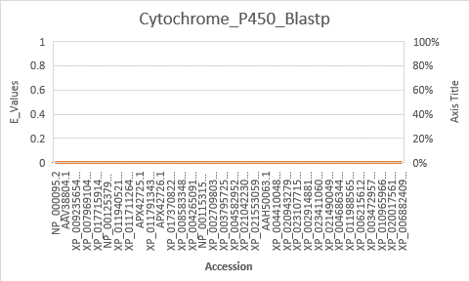

**Diagram Tree of Cytochromes P450:**

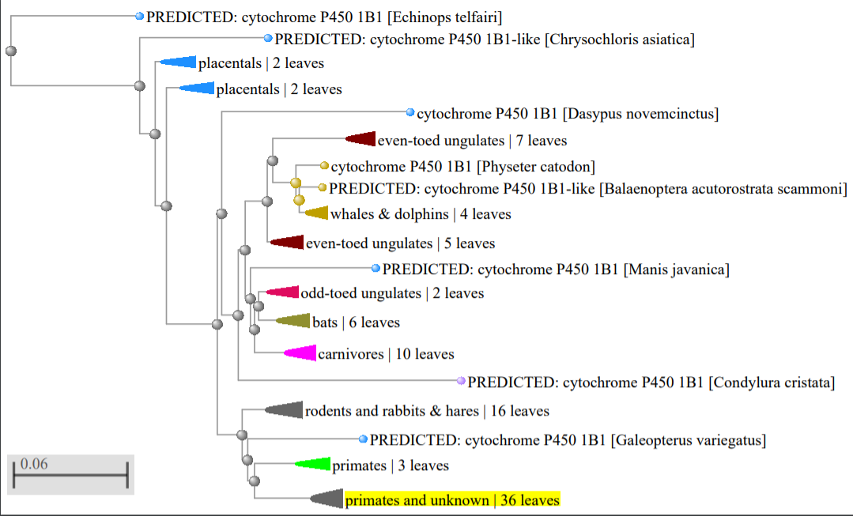

**C2H2 Zinc Fingers**

Blast Result: C2H2 Zinc Fingers Fasta file:

** **

Blast Result in Excel format:



**Analysis:**



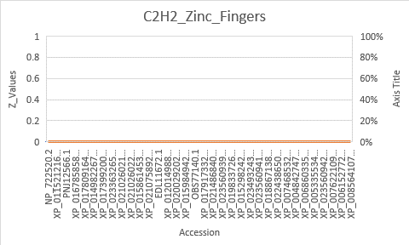

**Diagram Tree of C2H2 Zinc Fingers:**

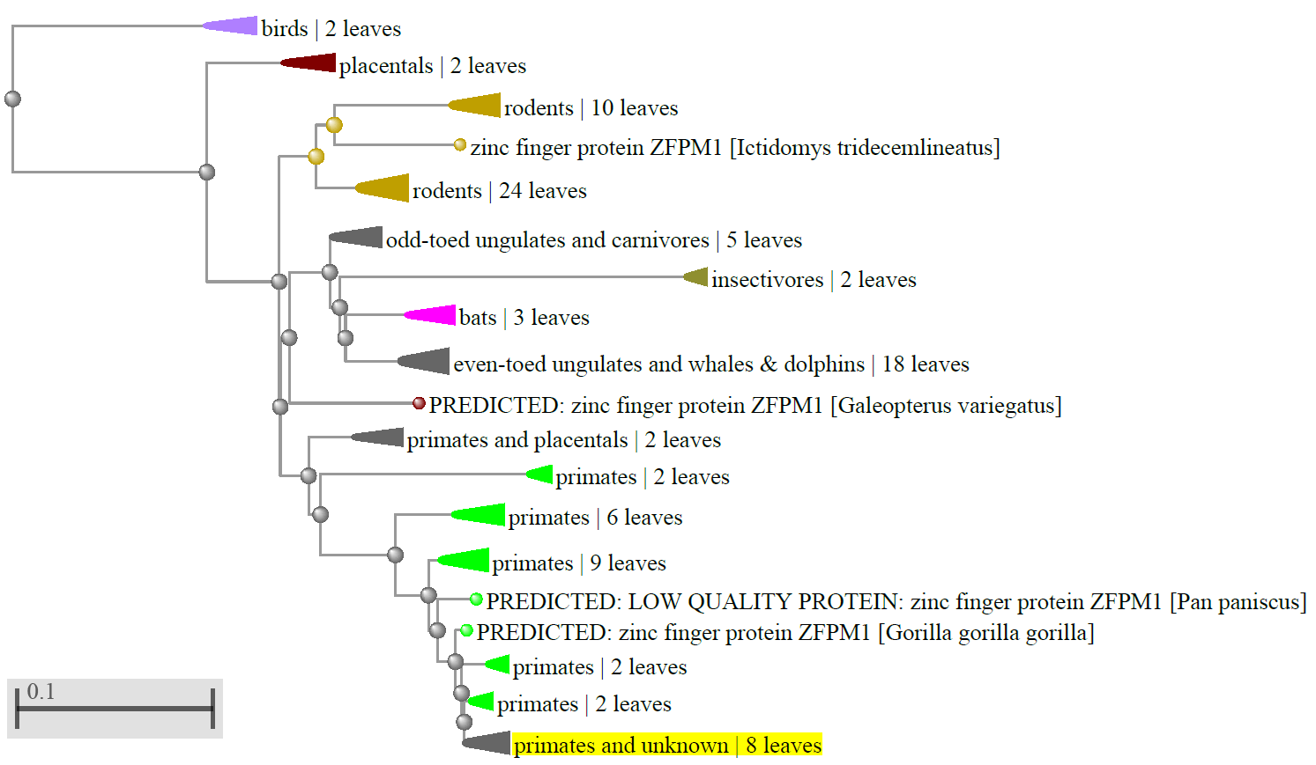

**PSI_BLAST RESULTS**

**Neuroglobin**

Blast Result:

First Iteration Second Iteration Third Iteration

  

Blast Result in Excel format:

First Iteration Second Iteration Third Iteration

  

Neuroglobin Fasta file:



Diagram Tree of Neuroglobin

**  **

**Analysis:**



**Third Iteration Neuroglobin Tree:**

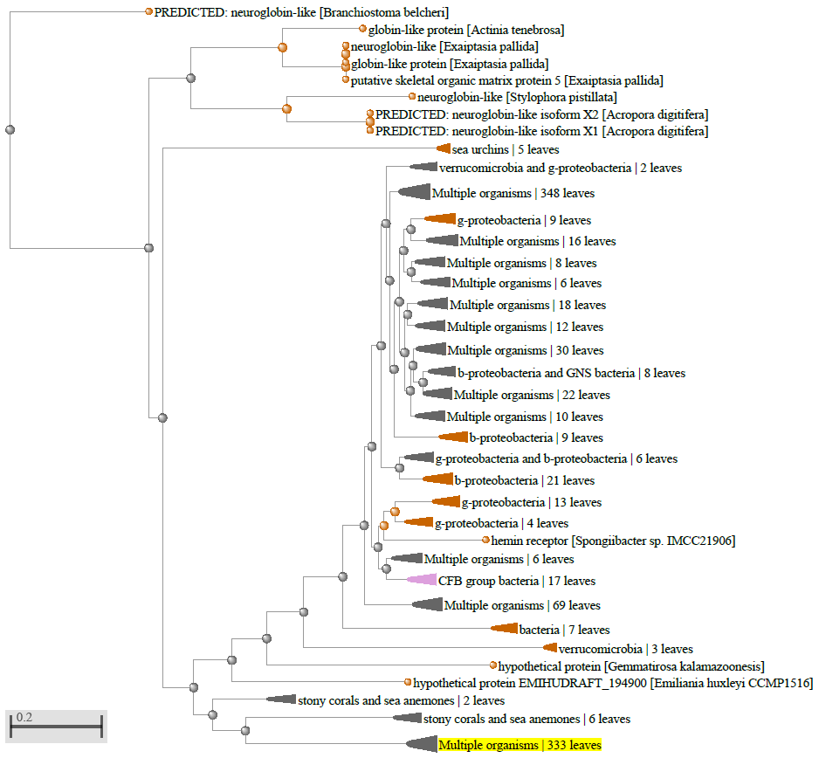

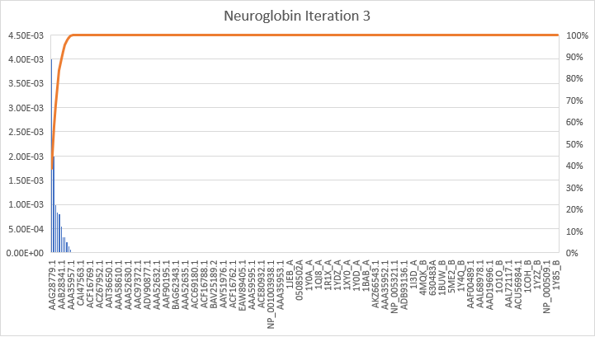

**Note**: Accession is defined in X-axis and Y-axis has the E values defined

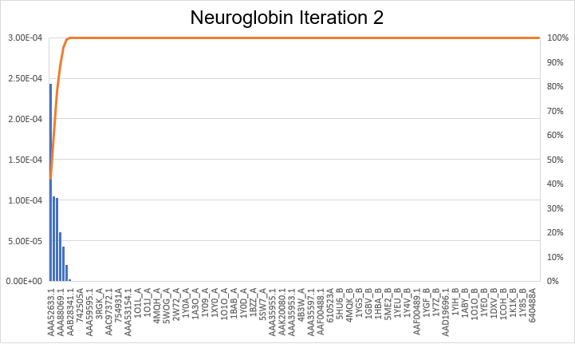

**Note**: Accession is defined in X-axis and Y-axis has the E values defined

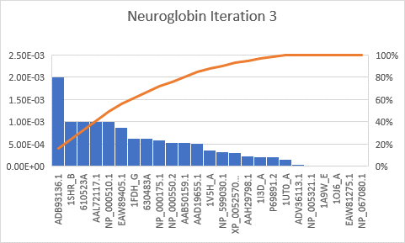

**Note**: Accession is defined in X-axis and Y-axis has the E values defined

I plotted the Histogram; you can notice the different curve ranges

**PSSM:**

The Resultant matrix available as .txt file







PSSM: cd08920

Hot spot Is the important residue. Altering the green spots will cause disease

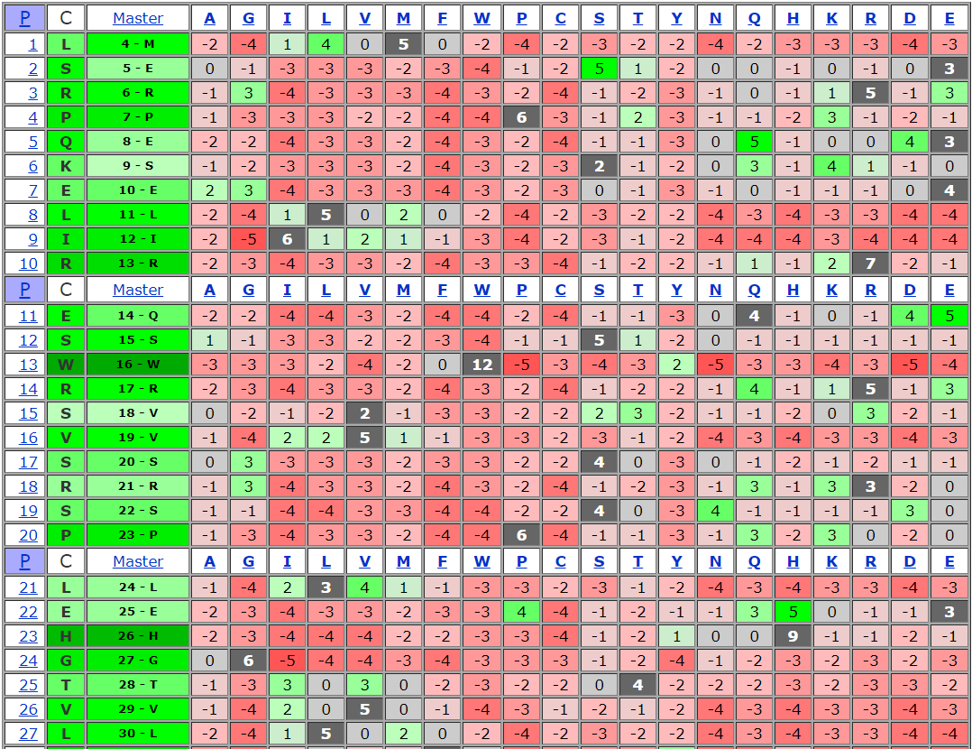

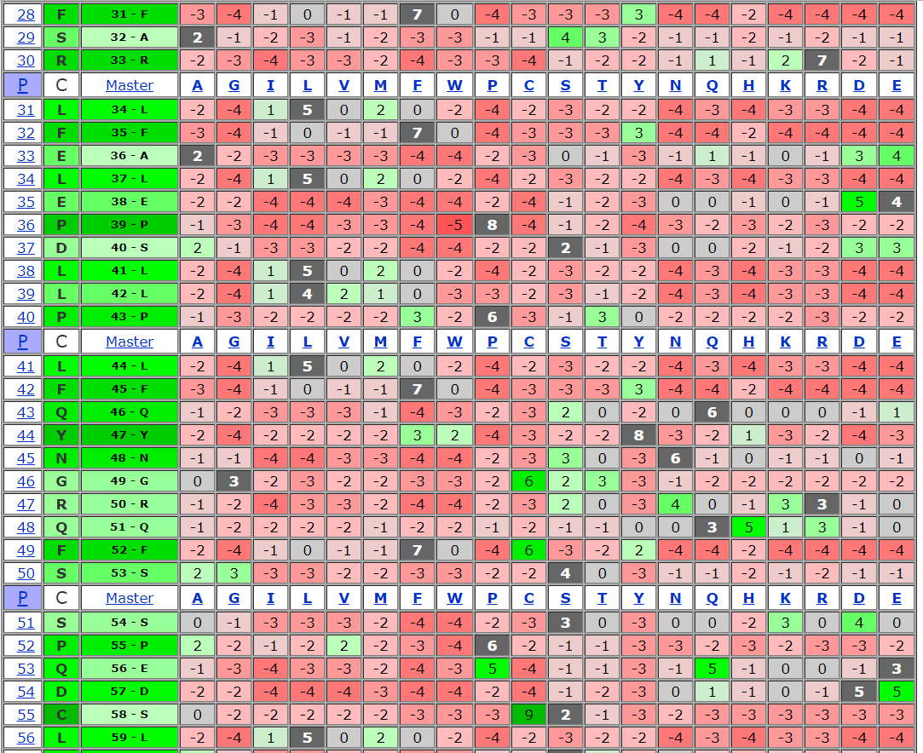

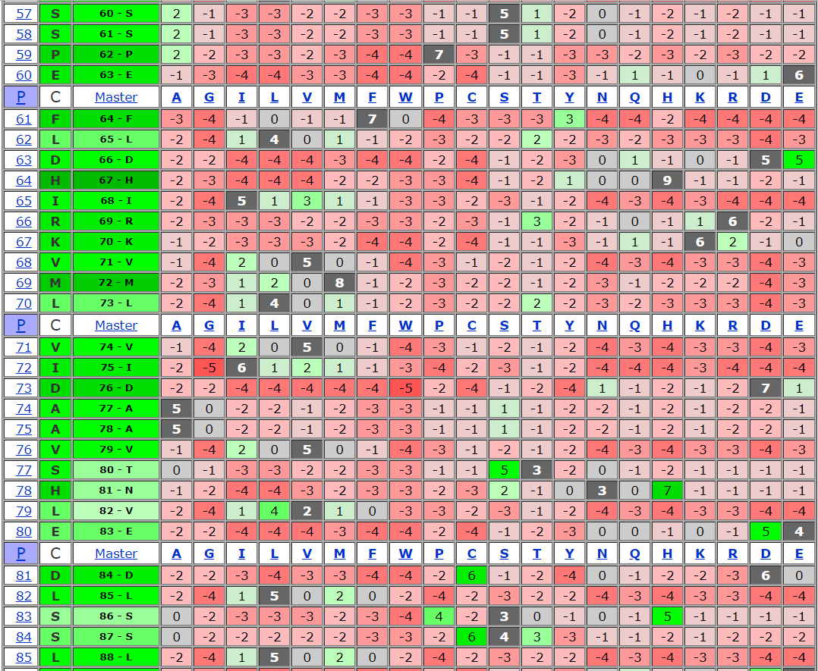

**Alignment:**

**2nd- iteration – Multiple Alignment**

[**https://www.ncbi.nlm.nih.gov/projects/msaviewer/?key=4WhLpcZqCa_FRDeg5lUBps9mcqe7CveZSTPHwDEhwPwlHc4C847SSX65W589duRWHg9hri_CAKongTznCpAnsRmCMIM4rAaEG704ijKOM5Mm**](https://www.ncbi.nlm.nih.gov/projects/msaviewer/?key=4WhLpcZqCa_FRDeg5lUBps9mcqe7CveZSTPHwDEhwPwlHc4C847SSX65W589duRWHg9hri_CAKongTznCpAnsRmCMIM4rAaEG704ijKOM5Mm)

**or**

[**https://goo.gl/kggzPc**](https://goo.gl/kggzPc)

**3rd- iteration – Multiple Alignment**

[**https://goo.gl/1YCMY2**](https://goo.gl/1YCMY2)

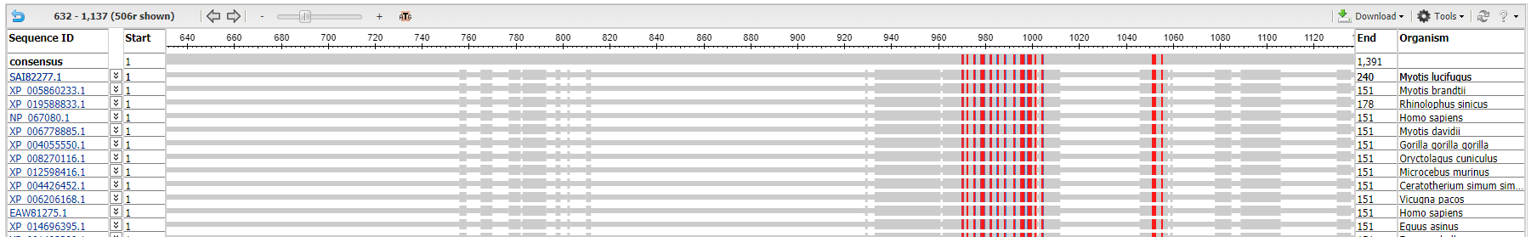 **2nd- iteration – Multiple Alignment**

**Cytochromes P450**

**Alignment Result**:

Blast Result:

First Iteration Second Iteration Third Iteration

  

Blast Result in Excel format:

First Iteration Second Iteration Third Iteration

  

Cytochromes P450 Fasta file:



Diagram Tree of Cytochromes P450

First Iteration Second Iteration Third Iteration

**  **

Analysis:



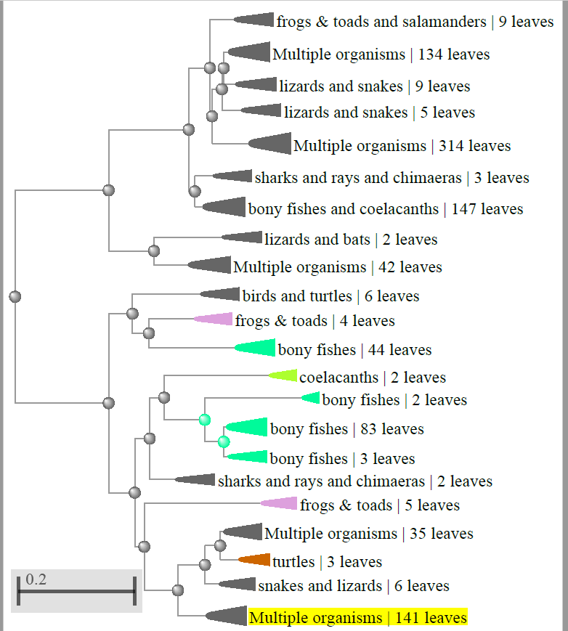

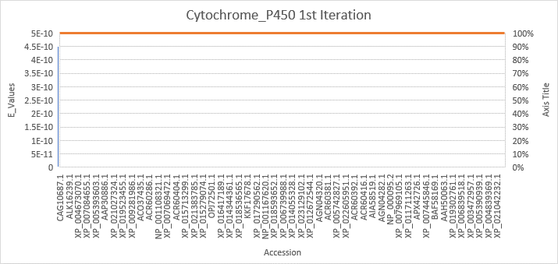

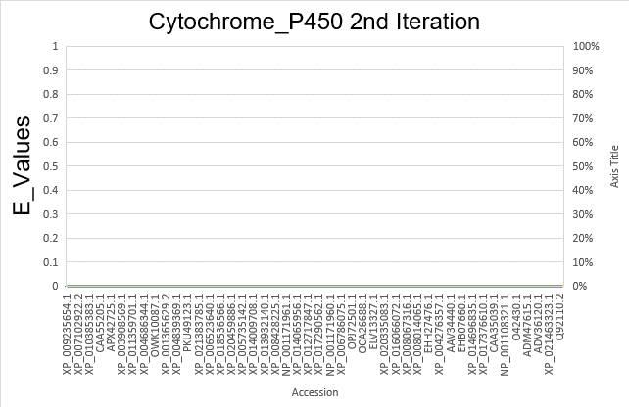

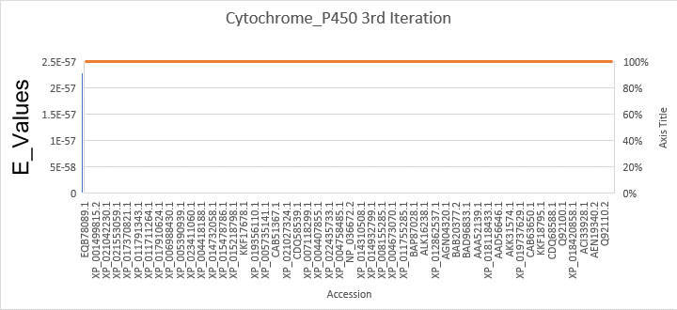

**Note**: Accession is defined in X-axis and Y-axis has the E values defined

PSSM:



Matrix View





PSSM ID : 306555

Hot spot Is the important residue. Altering the green spots will cause disease

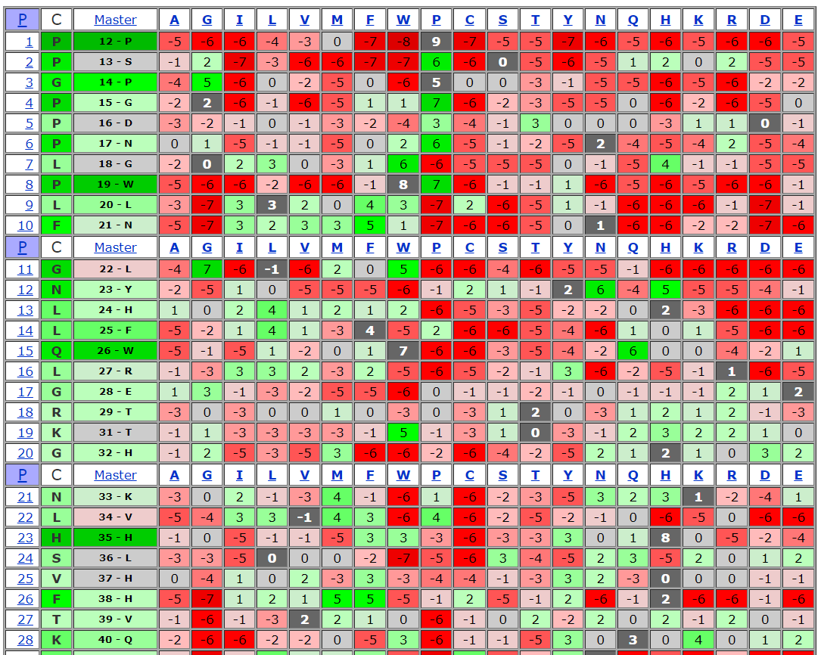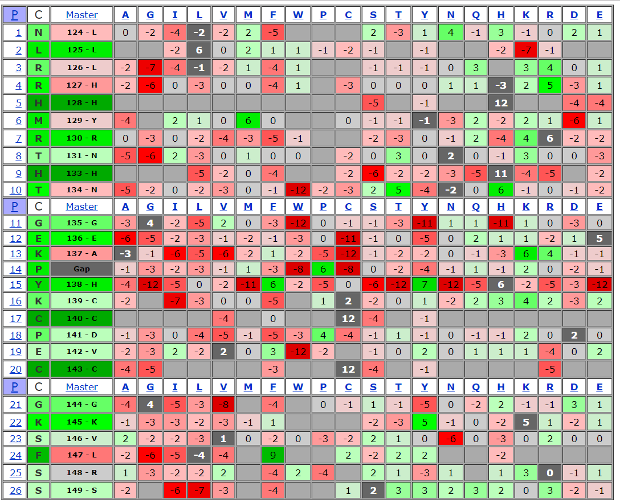

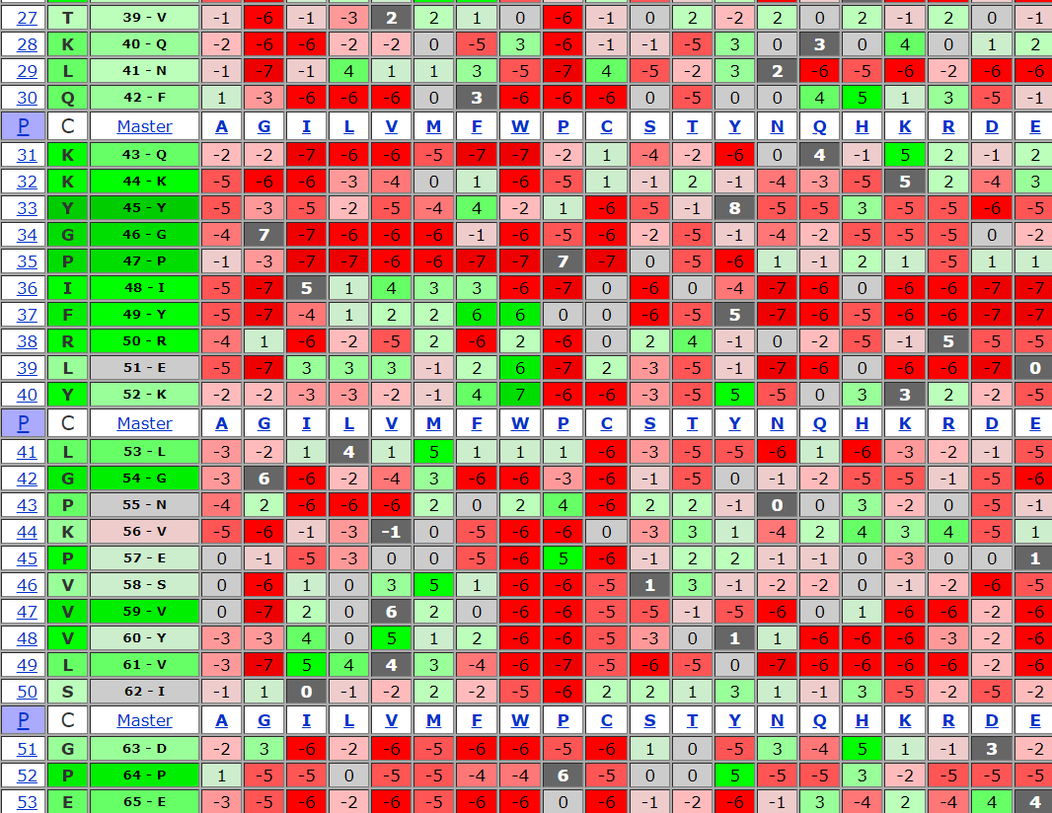

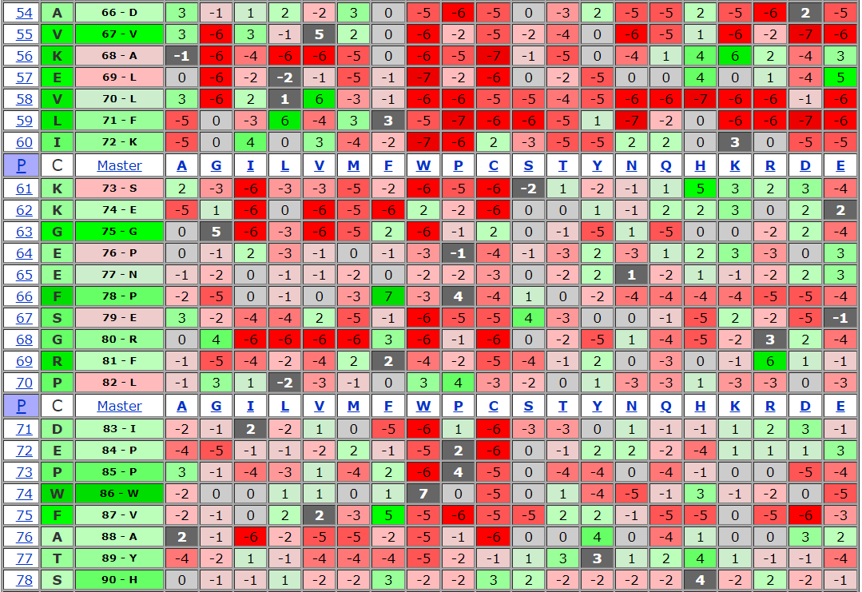

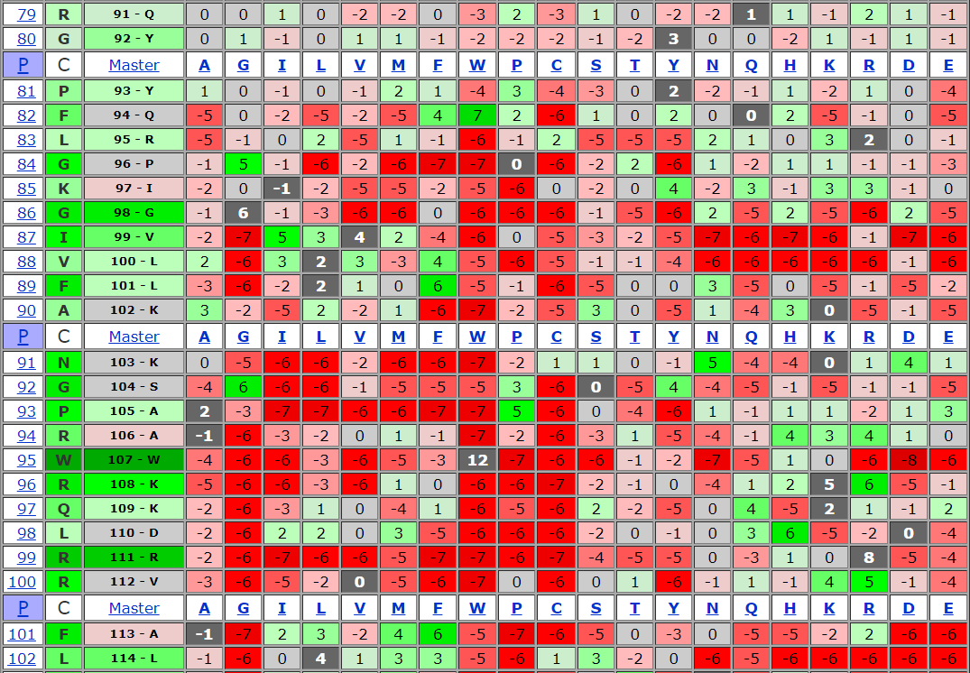

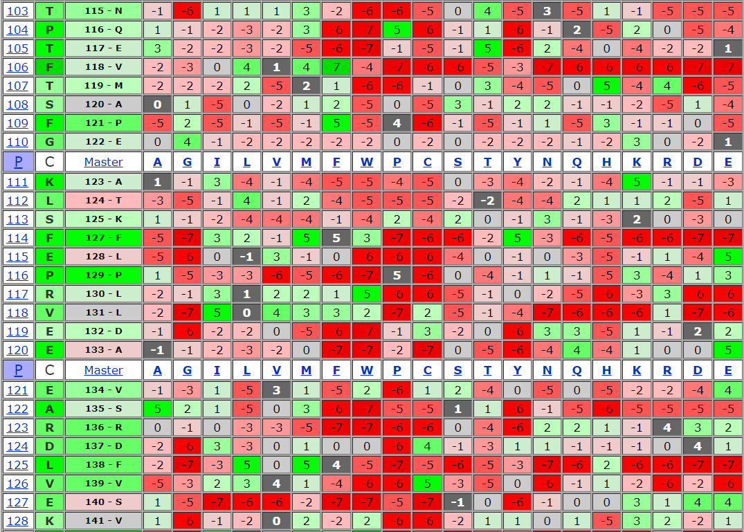

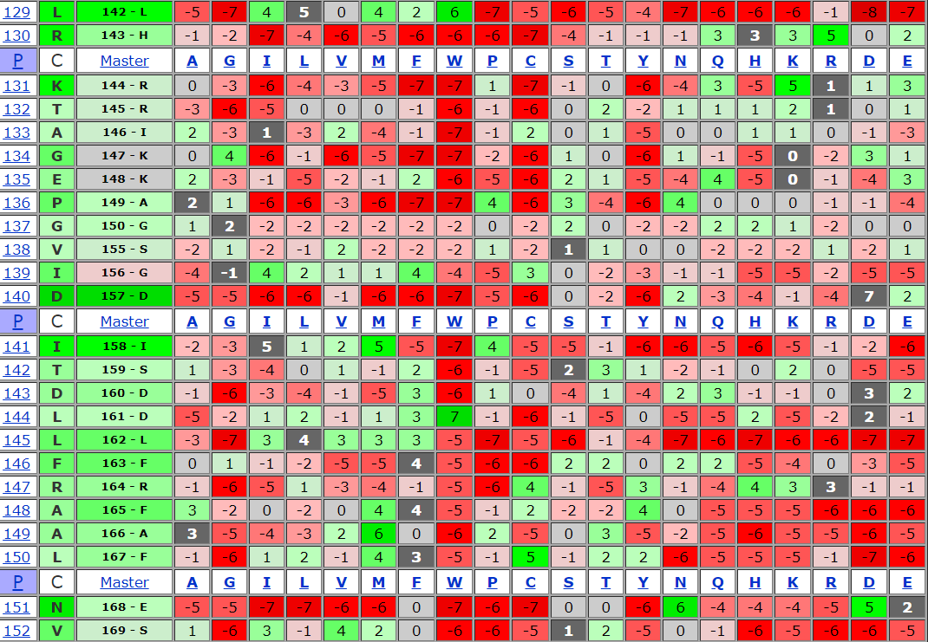

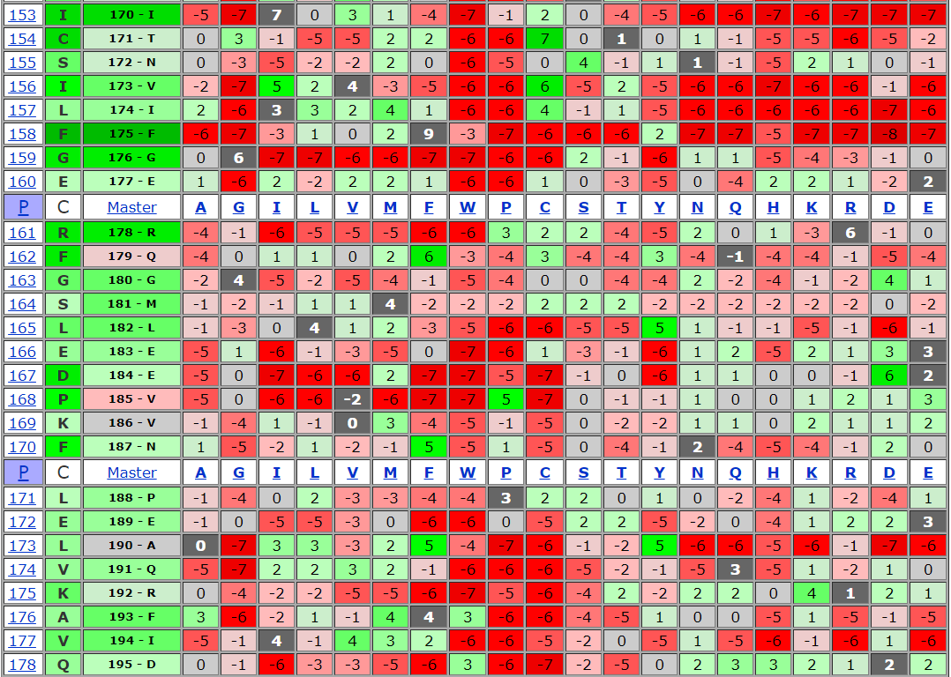

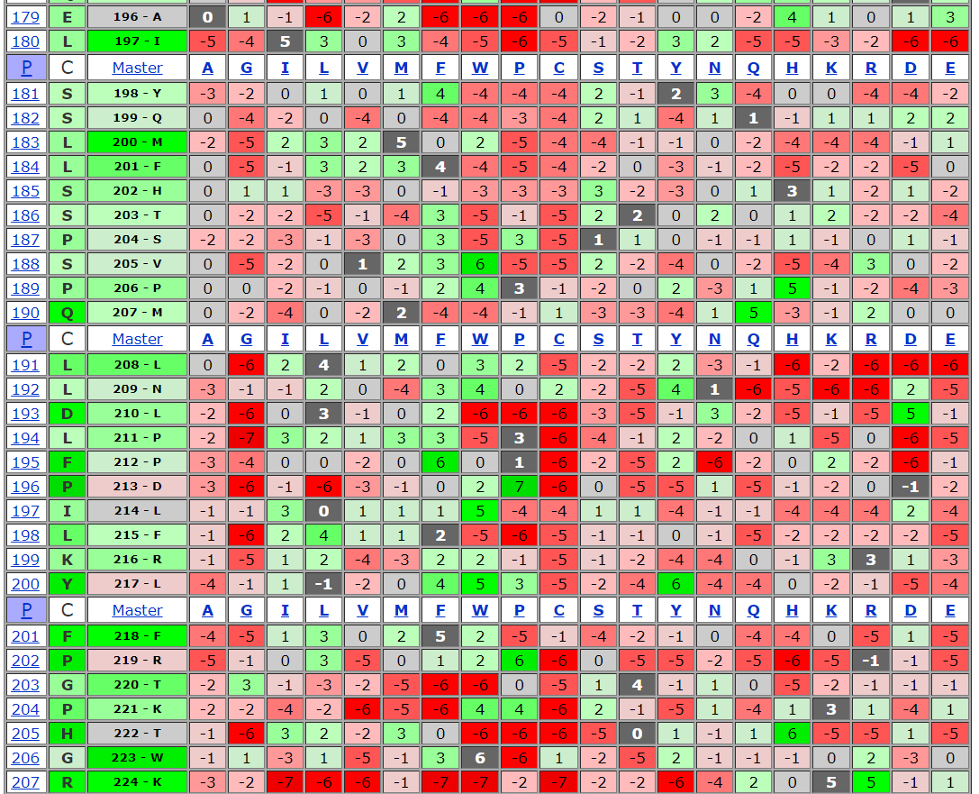

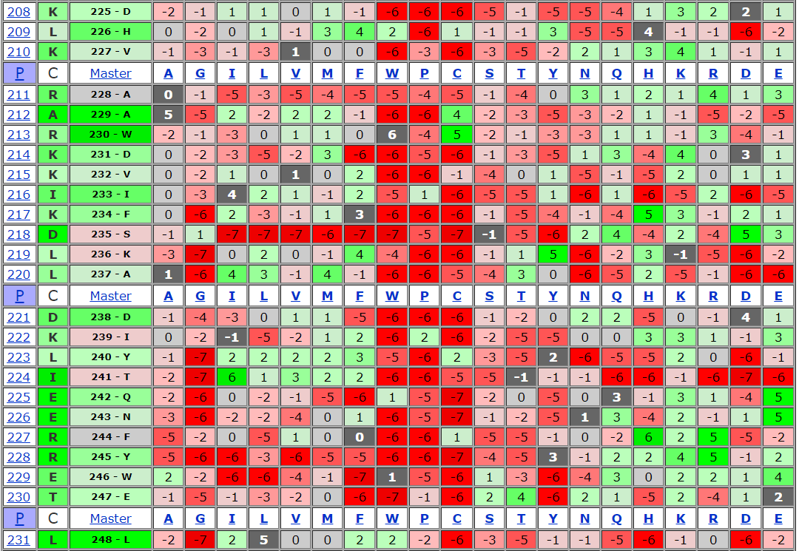

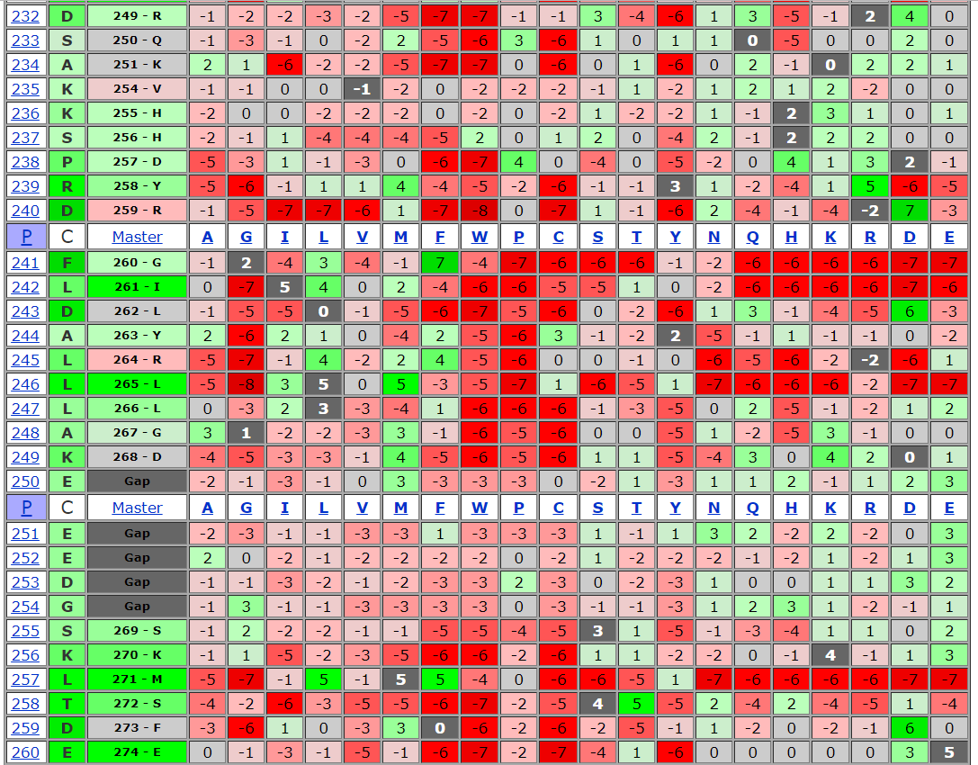

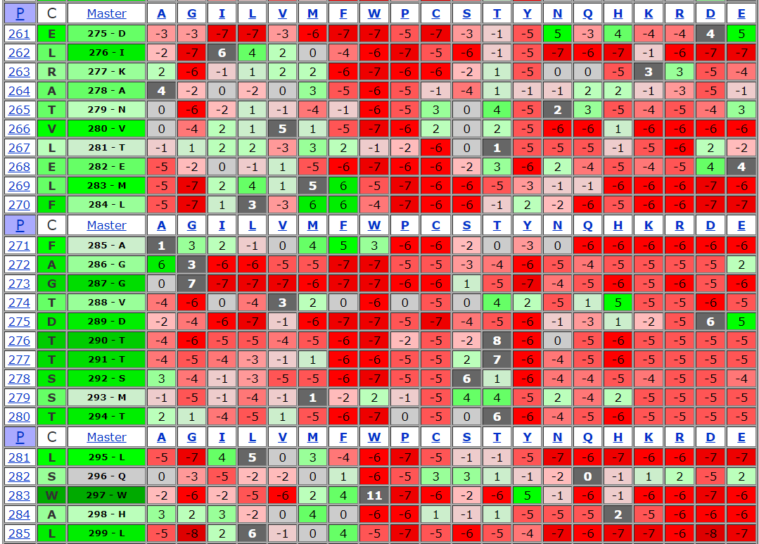

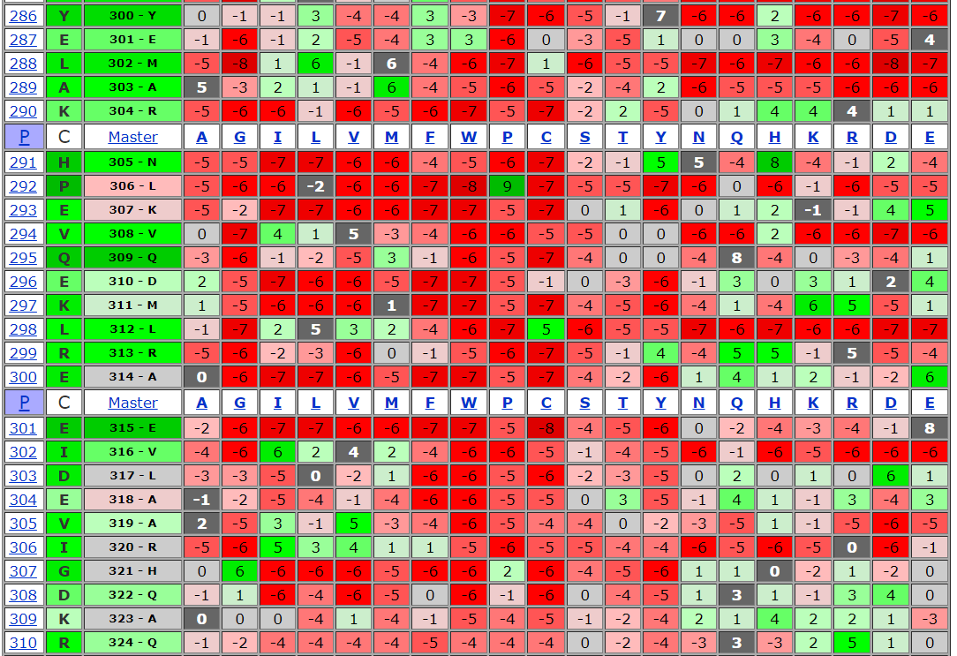

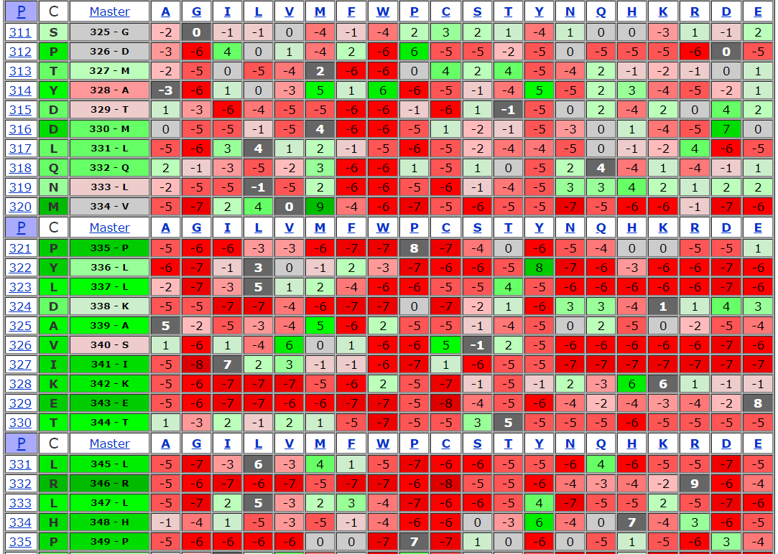

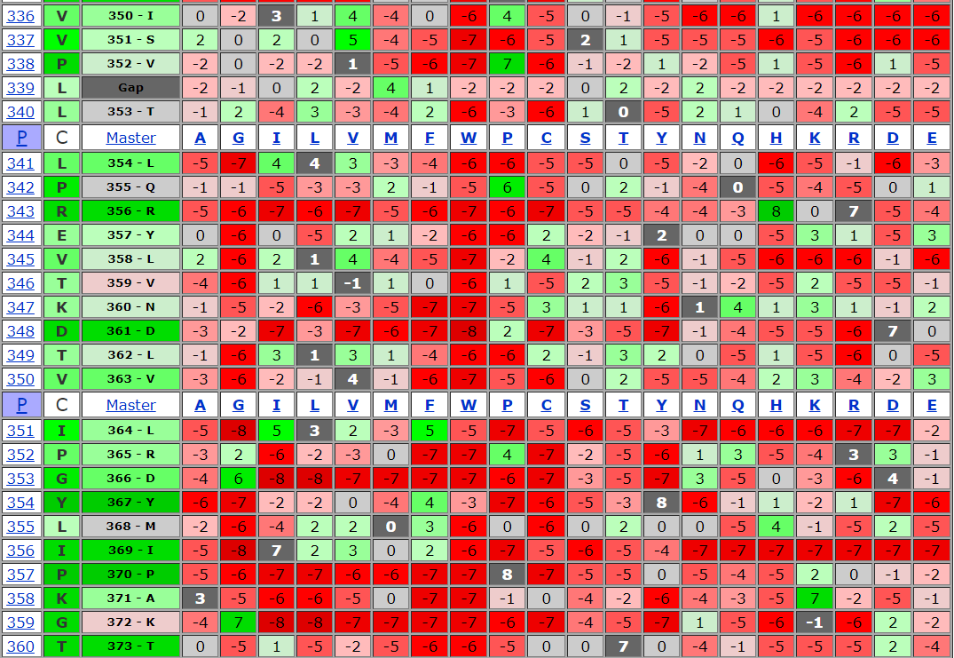

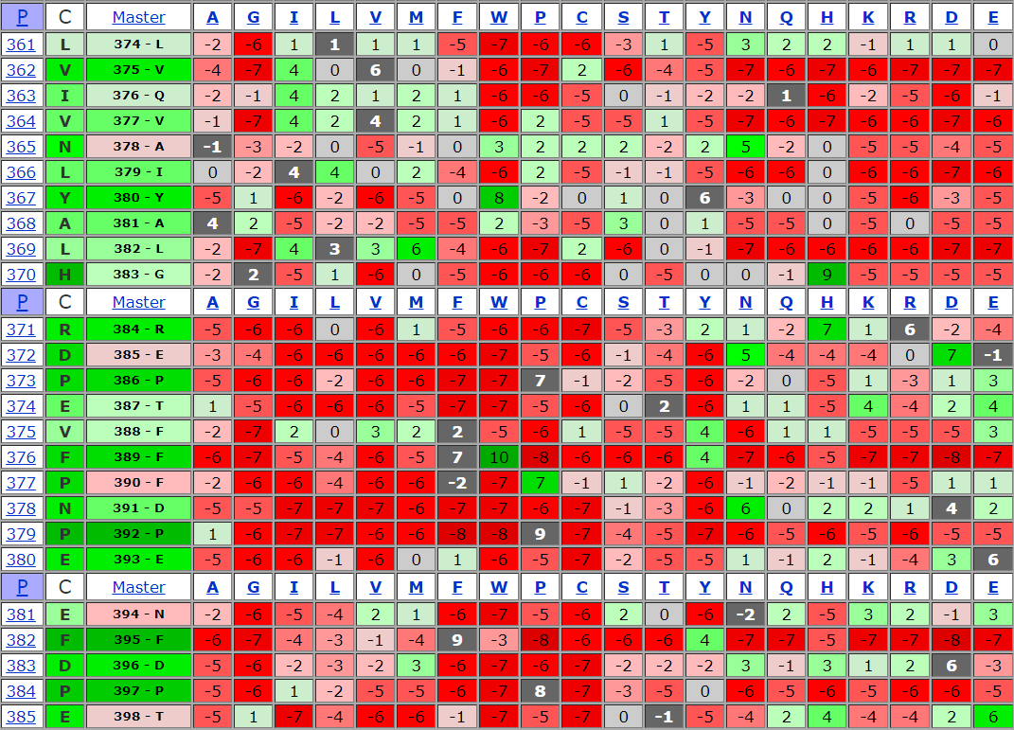

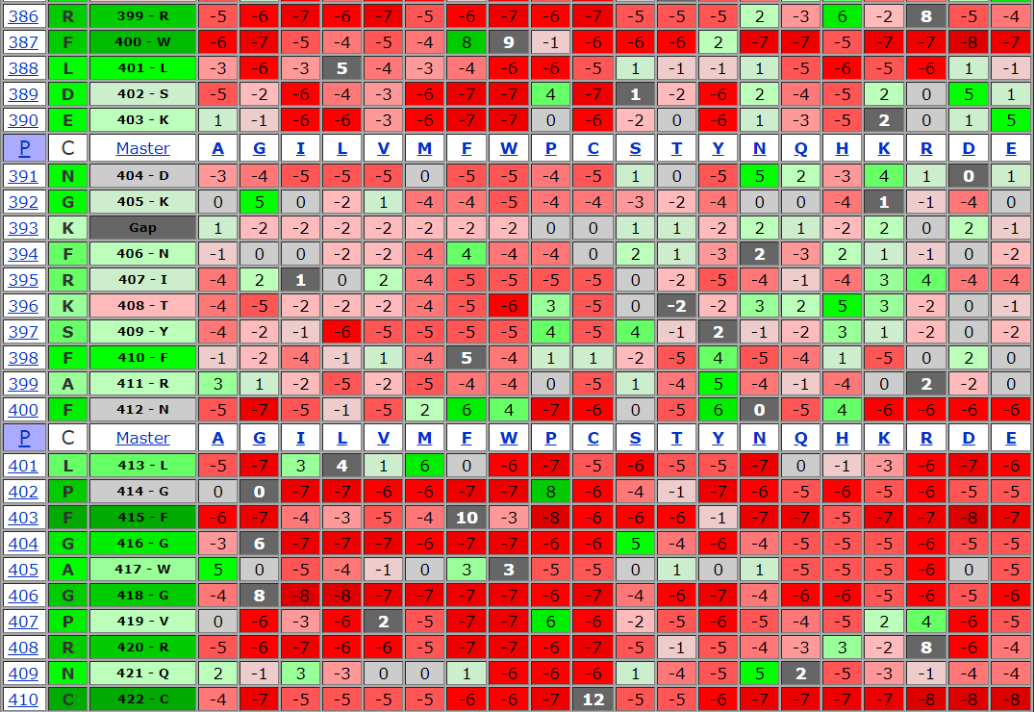

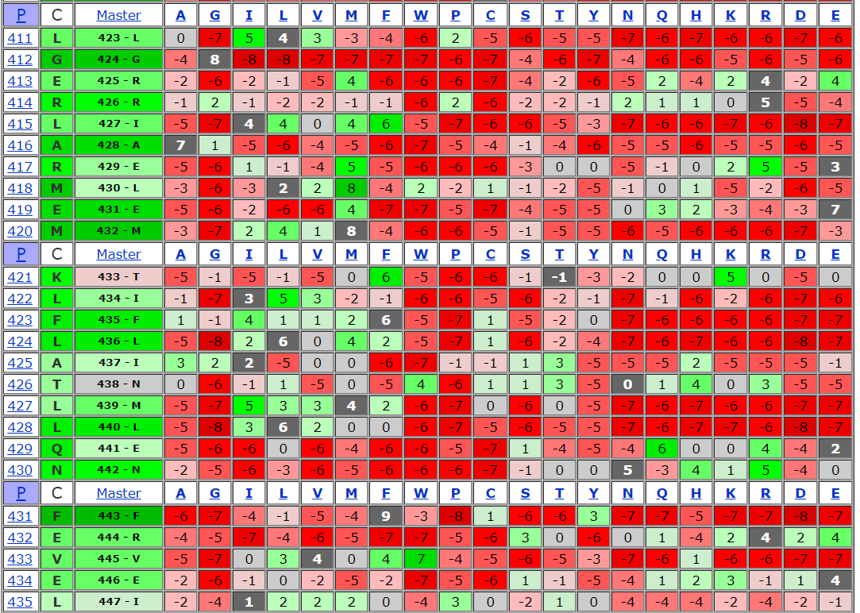

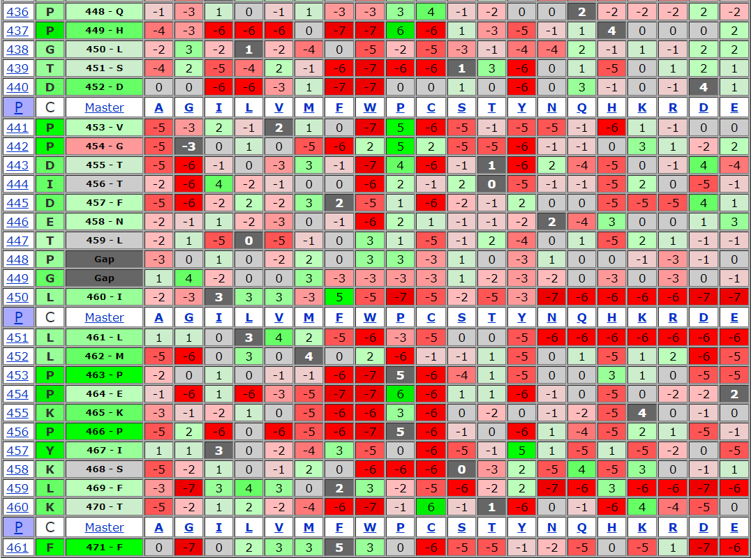

**Multiple Alignment:**

[**https://www.ncbi.nlm.nih.gov/projects/msaviewer/?key=31Z1m_hUN5H7egme2Gs_mPFYTJmFNMn9LlegpFZFp5hCealmlOq1LvhA3SmQv3Gf9inhEK98gBSnP7xZii6nD5k8sD24EoY6mwO4NLIwsy2m**](https://www.ncbi.nlm.nih.gov/projects/msaviewer/?key=31Z1m_hUN5H7egme2Gs_mPFYTJmFNMn9LlegpFZFp5hCealmlOq1LvhA3SmQv3Gf9inhEK98gBSnP7xZii6nD5k8sD24EoY6mwO4NLIwsy2m)

**or**

[**https://goo.gl/A2wiqb**](https://goo.gl/A2wiqb)

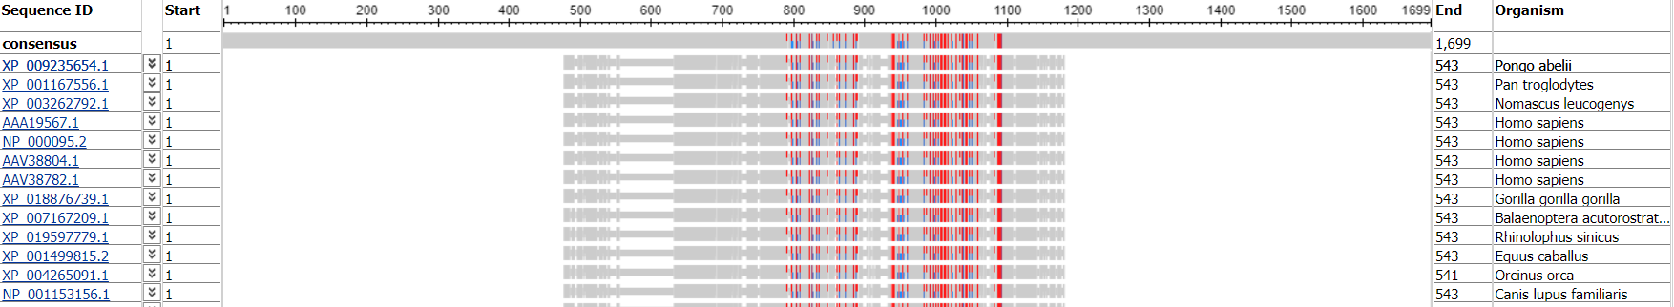

**C2H2 Zinc Fingers**

**Alignment Result**:

Blast Result:

First Iteration Second Iteration

 

Blast Result in Excel format:

First Iteration Second Iteration

 

C2H2 Zinc Fingers Fasta file:



Diagram Tree of C2H2 Zinc Fingers

** **

**Analysis**



**Diagram Tree of C2H2 Zinc Fingers:**



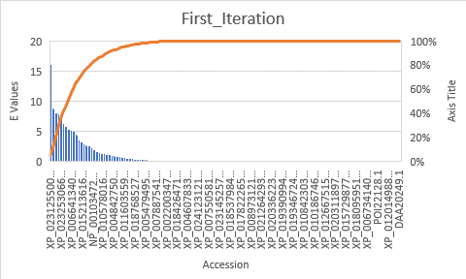

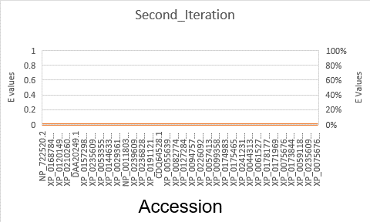

**PSSM**

The Matrix Value:





Hot spot is the important residue. Altering the green spots will cause disease

PSSM id is 316026



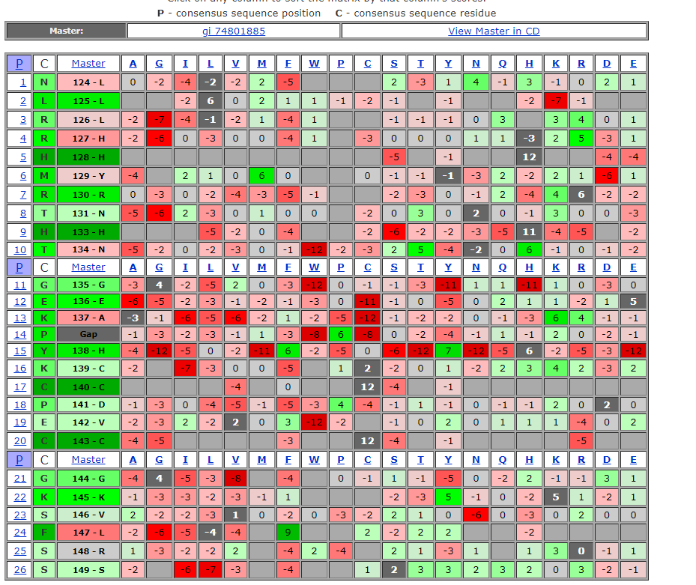

**Multiple Alignment:**

[**https://www.ncbi.nlm.nih.gov/projects/msaviewer/?key=LKWGaAunxGIIifptK5jMawKrv2p2xzpyotgsK9rKKxfO9iXpGGU5oWxbSWSCZEBE9DbIyoamqc6O5ZWDo_SO1bDmmeeRyK_gstmR7pvqmveP**](https://www.ncbi.nlm.nih.gov/projects/msaviewer/?key=LKWGaAunxGIIifptK5jMawKrv2p2xzpyotgsK9rKKxfO9iXpGGU5oWxbSWSCZEBE9DbIyoamqc6O5ZWDo_SO1bDmmeeRyK_gstmR7pvqmveP)

**or**

[**https://goo.gl/p2F2sM**](https://goo.gl/p2F2sM)

